# Exemplar: Adding a role-playing dimension

## **Overview**

In the exercise *Adding a role-playing dimension,* you were asked to configure the Date table as a role-playing dimension for the order date and shipping date. Your task was also to create a measure to calculate the total sales for August based on the shipping date by using the USERELATIONSHIP function in DAX.

Your tasks in this exercise were to:

* Download and connect to the required dataset.
* Create an active and inactive relationship between the Sales and the Date table.
* Create a measure within your data model by overriding the default relationship.

This reading provides you with a step-by-step guide for completing these tasks. It also includes screenshots that you can compare against your work.

You can also review [*Creating quick measures*](https://www.coursera.org/learn/data-modeling-in-power-bi/lecture/xZZBs/creating-quick-measures) and [*Creating custom measures with DAX*](https://www.coursera.org/learn/data-modeling-in-power-bi/lecture/m25v9/creating-custom-measures-with-dax).

## **Step 1: Download and connect to the Adventure Works dataset.**

1. Download and save the workbook Adventure Works Date.xlsx. The workbook contains two tables of data: Sales and Date. The Sales sheet contains several columns such as ShippingDate and SalesAmount which can be viewed by using the scrollbar.

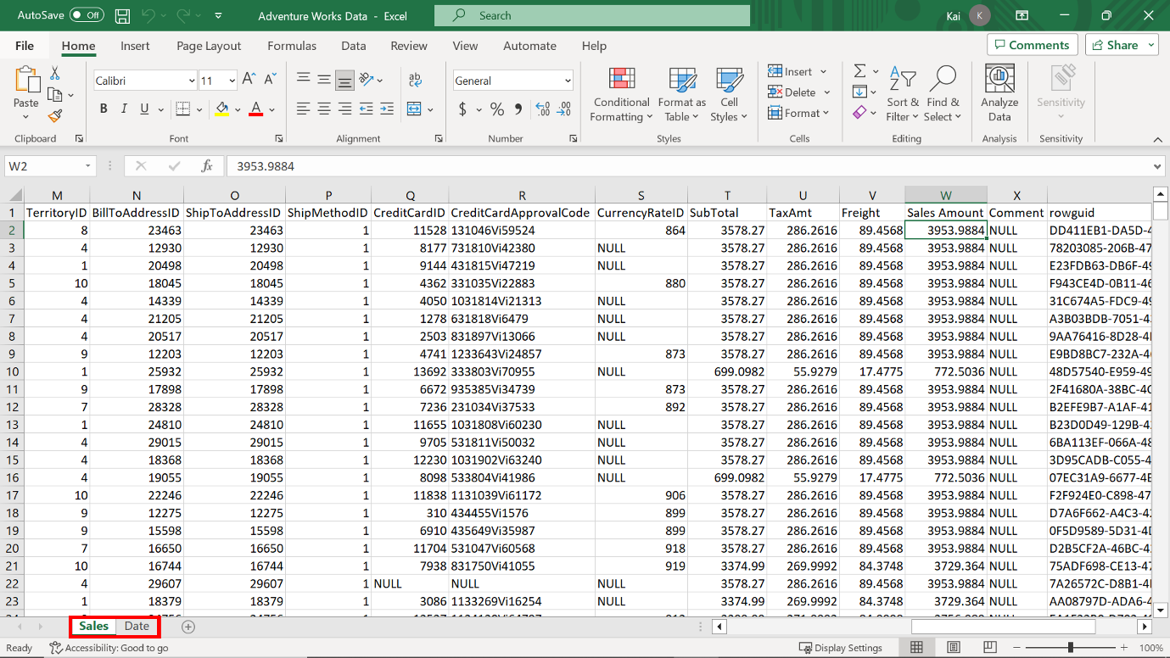

2. Load the data to Power BI, ensuring you load both data tables available in the workbook to the data model, that is the Sales table and the Date table.

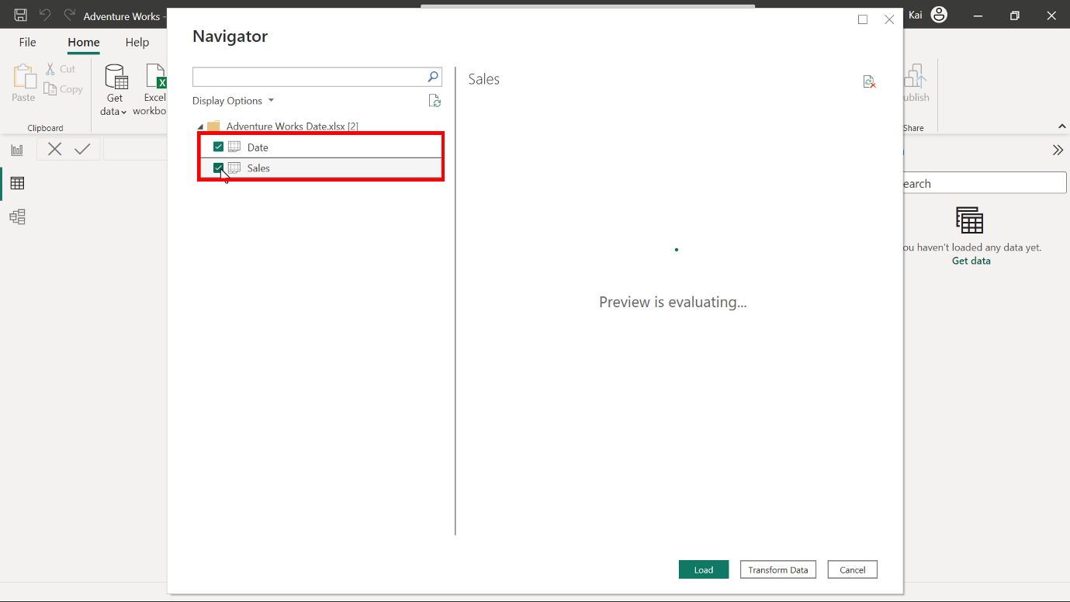

## **Step 2: Review the data model and establish relationships.**

1. Ensure an appropriate relationship between the Sales table and the Date dimension table is established.

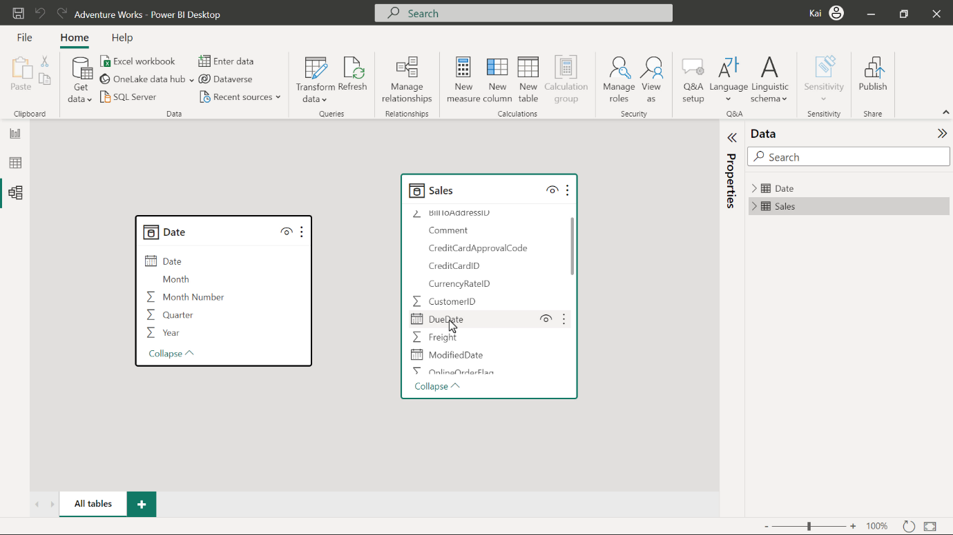

After you Load the data, Power BI attempts to establish the relationship between the tables. If the relationship is missing, create a manual relationship between the sales and date table based on the order date. That is the active relationship.

You can drag and drop the Date field from the Date table to the Order date field in the Sales table. Alternatively, navigate to Manage relationship option from the model view of Power BI desktop. This opens the Manage relationship dialog box. Select New to create a new relationship.

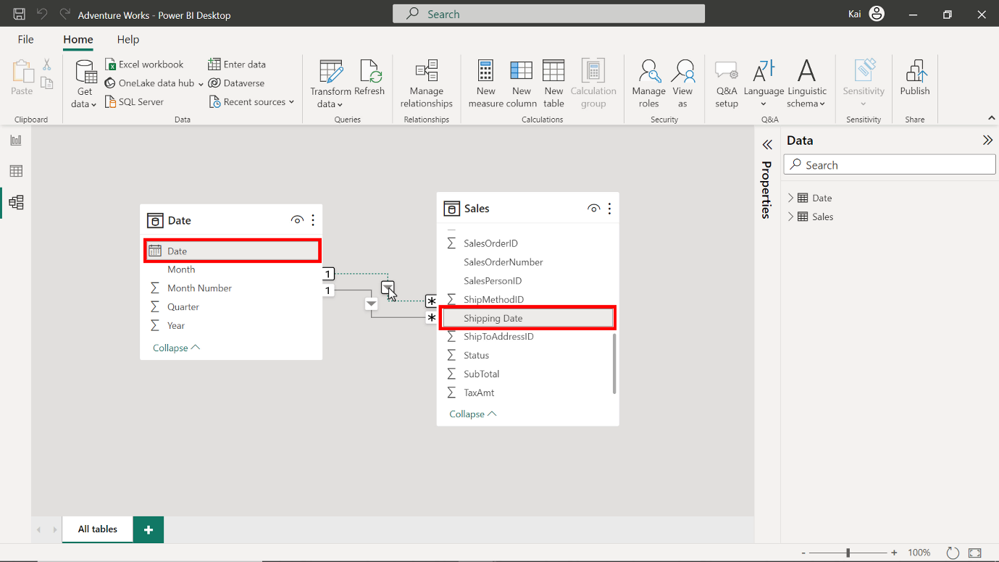

1. Create another relationship between the Shipping date field from the Sales table and the Date field from the Date table. This must be an inactive relationship as the Date table is the role-playing dimension in the data model.

You can repeat the drag-and-drop process. Select the Shipping date column from the Sales table, then drag and drop it to the Date column of the Date table. The dashed line between the Date and the Sales table represents this relationship.

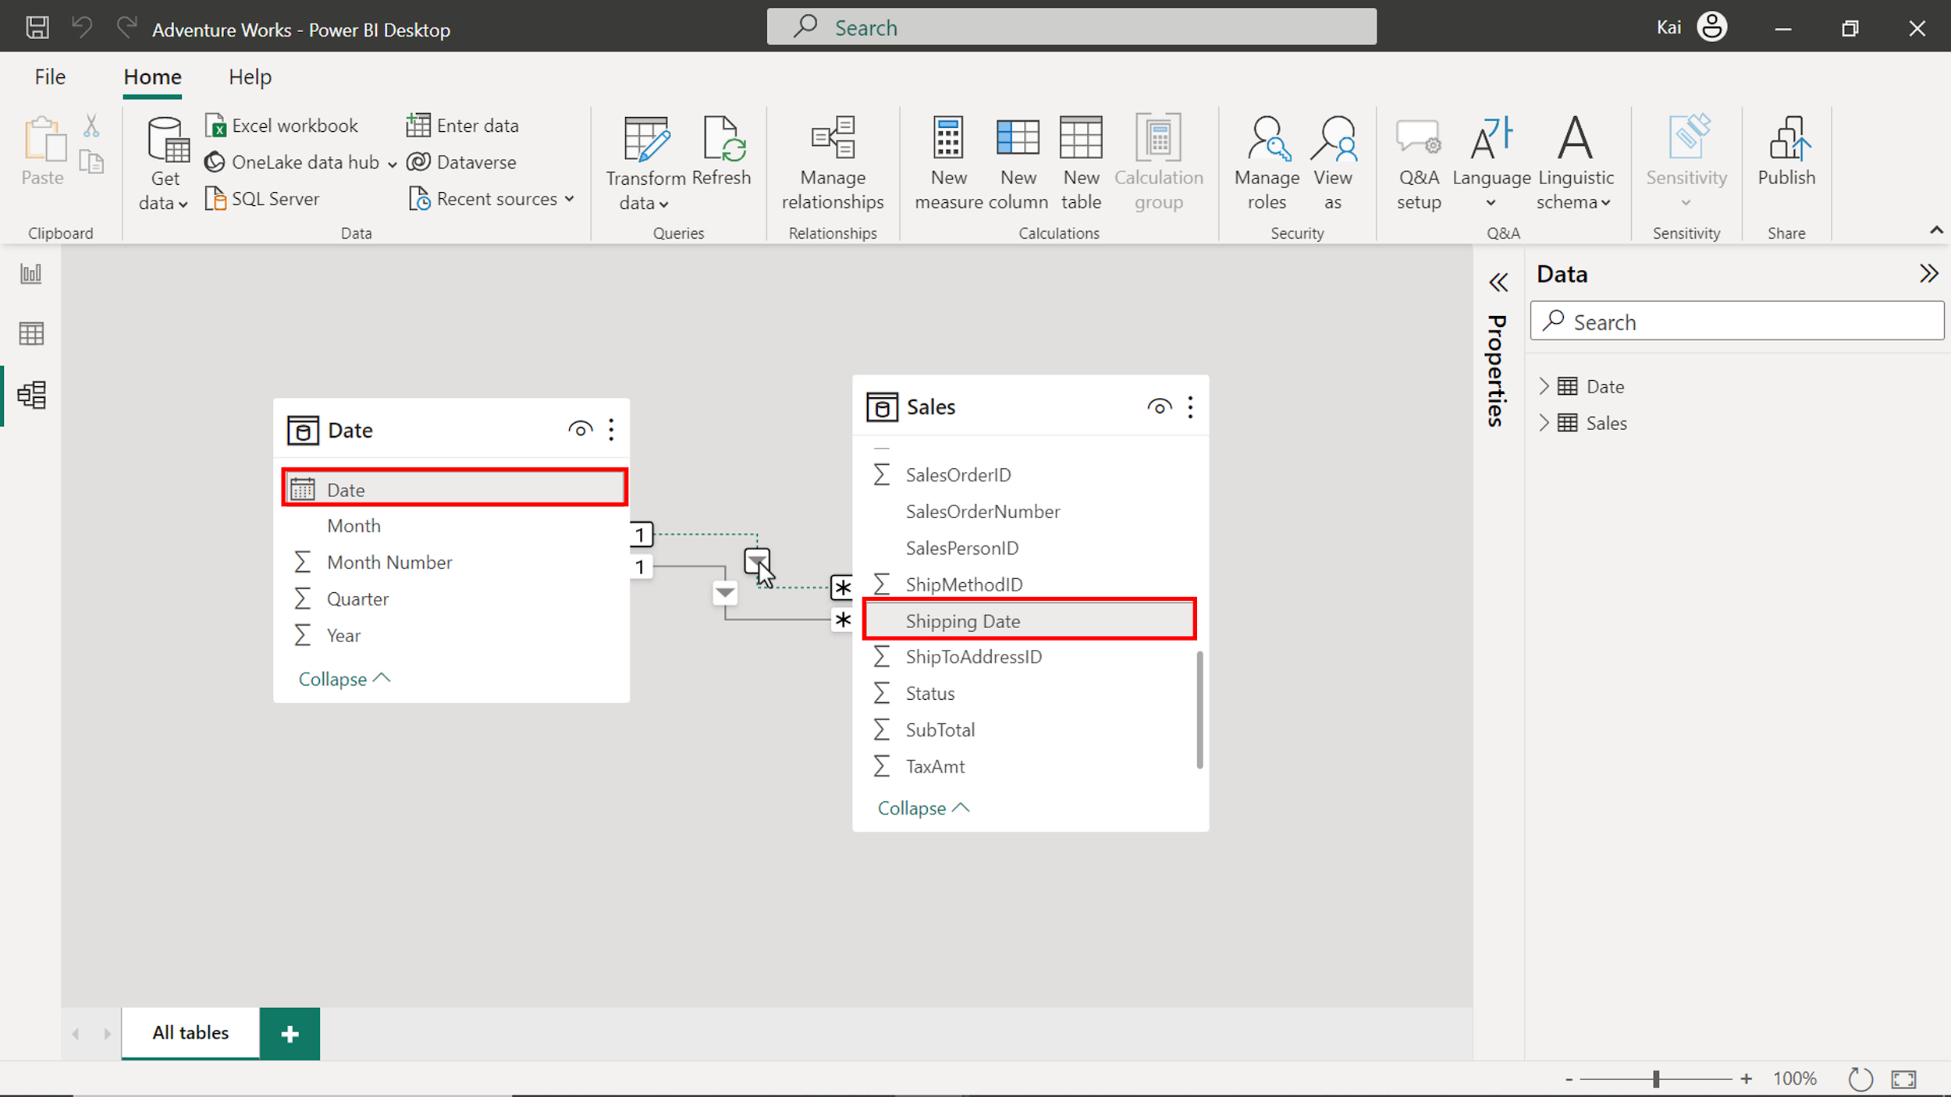

## **Step 3: Create Measure by writing DAX expression.**

1. Once you configure the Date table as a role-playing dimension and establish the relationship in the data model, create a new measure on the Sales table called August Sales by Shipping date.

Go the Data view. On the Data pane, select the Sales table and then the New measure option from the Calculations group. This action expands the DAX formula bar. Add the DAX expression to compute the measure August sales by shipping date.

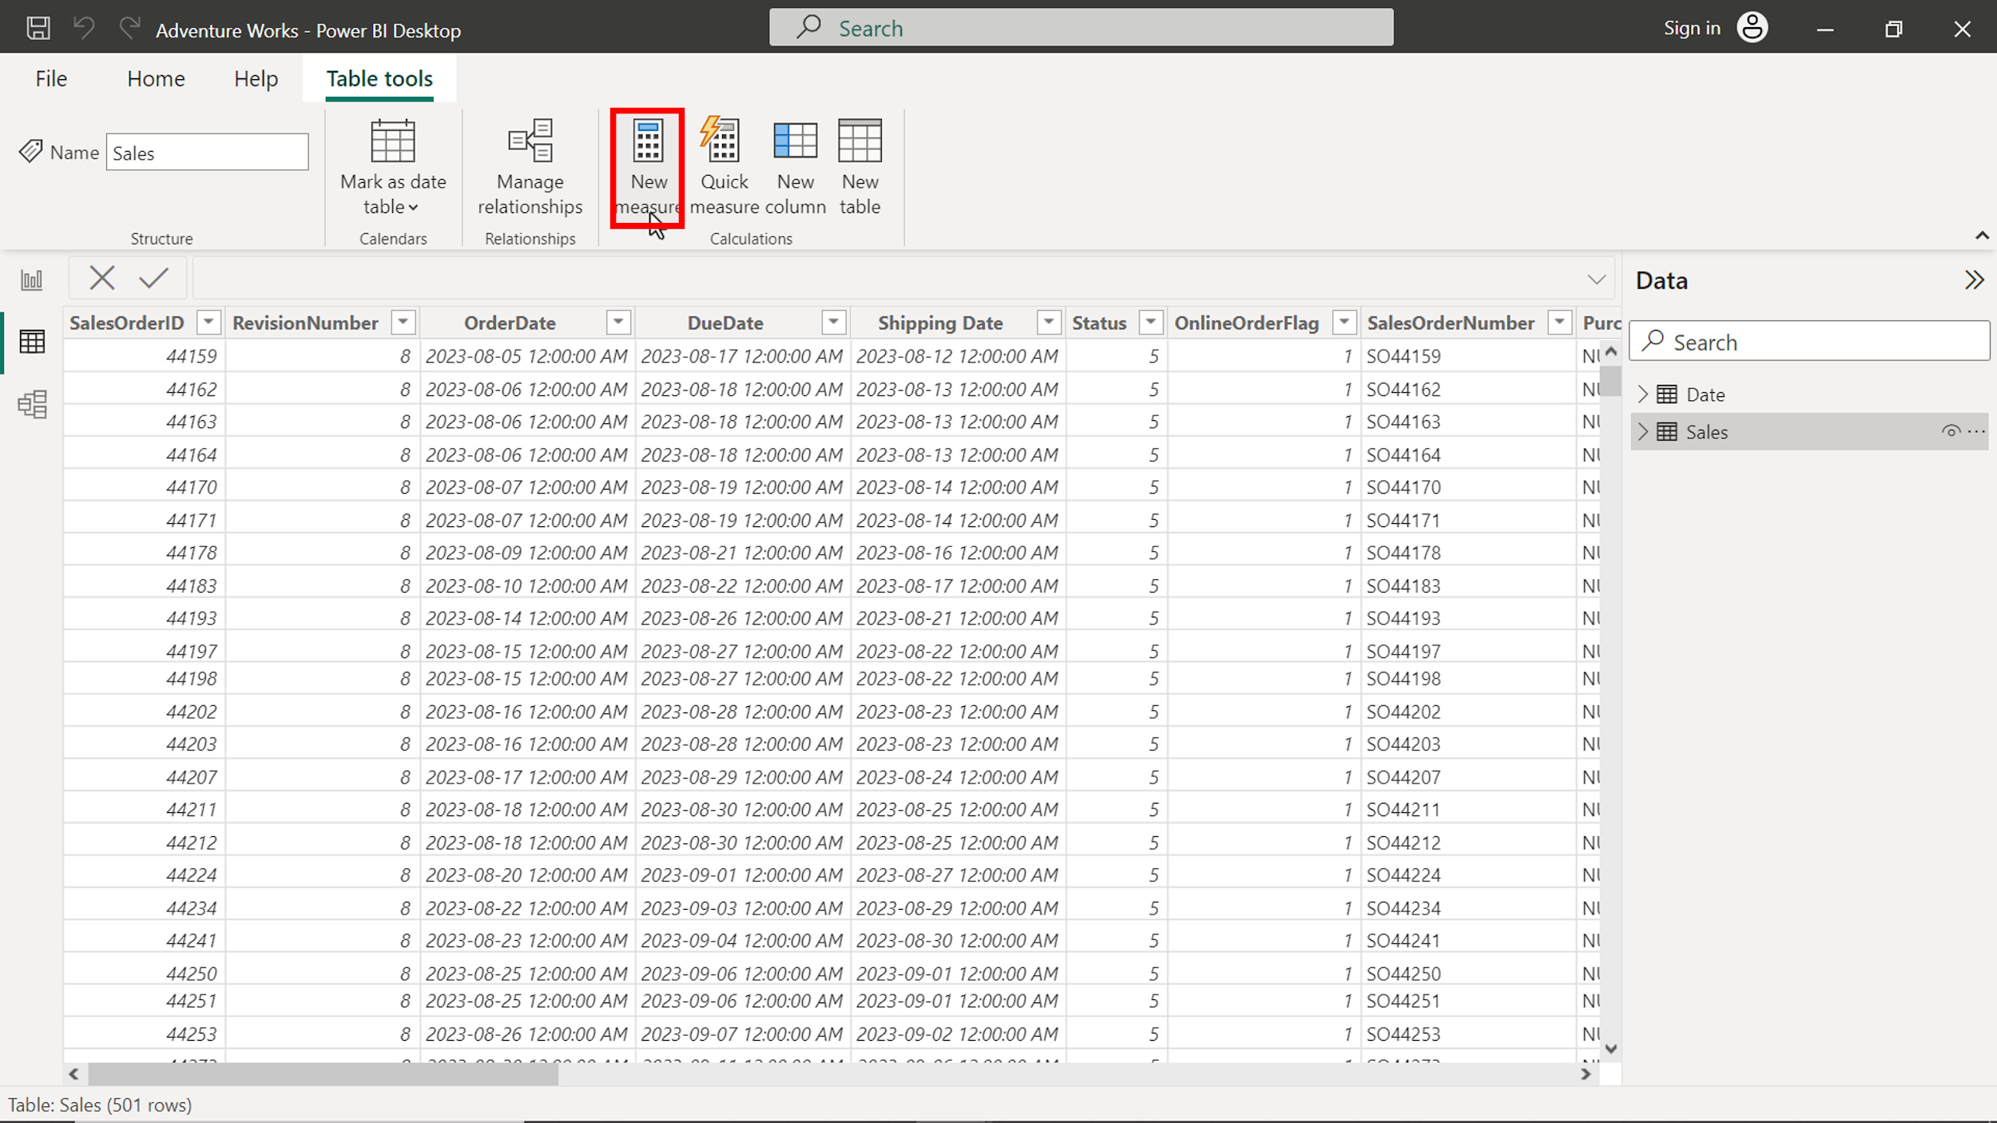

1

2

3

4

5

6

7

August Sales by Shipping date =

CALCULATE

(

SUM(Sales[Sales Amount]),

FILTER('Date', 'Date'[Month] = "August"),

USERELATIONSHIP(Sales[Shipping Date], 'Date'[Date])

)

* The expression calculates the total sales for August based on the shipping date.
* SUM calculates the total Sales column from the Sales table
* FILTER filters the values for August from the Month column of the Date table
* USERELATIONSHIP overrides the table relationship to consider the shipping date instead of the order date, which is the default relationship.

Once you execute the code, a new measure appears in the data pane under the Sales table.

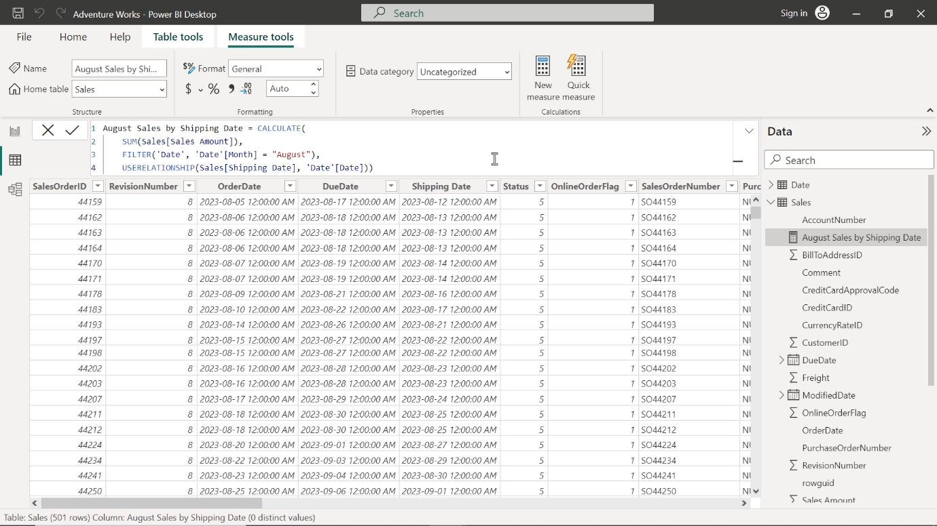

1. Format the measure as currency with 2 decimal places.

To format the measure, select the newly created measure from the data pane. Navigate to the formatting group in the Measure tools tab of Power BI. Select Currency from the Format drop-down menu.

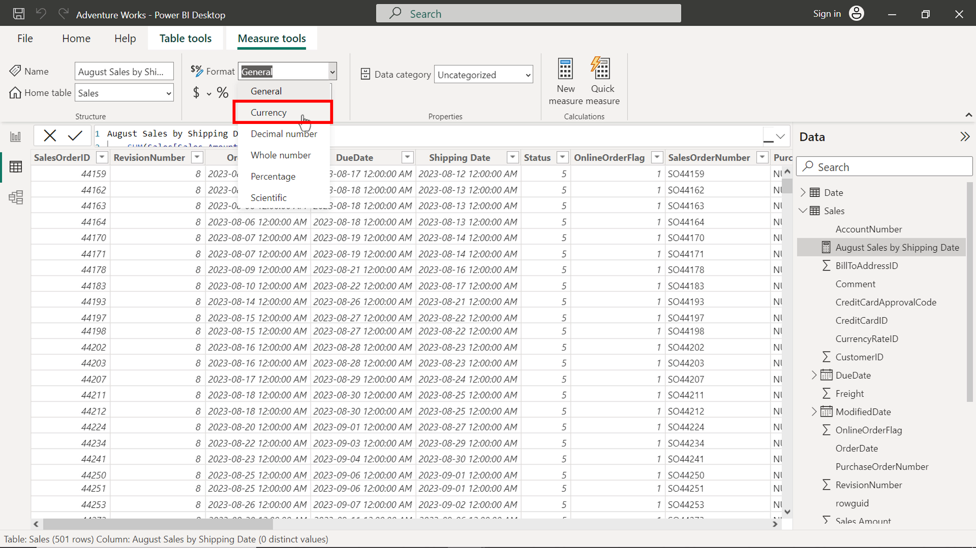

Enter 2 in the decimal places (which is auto by default). This action formats the measure as Currency within 2 decimal places and is good for visualization.

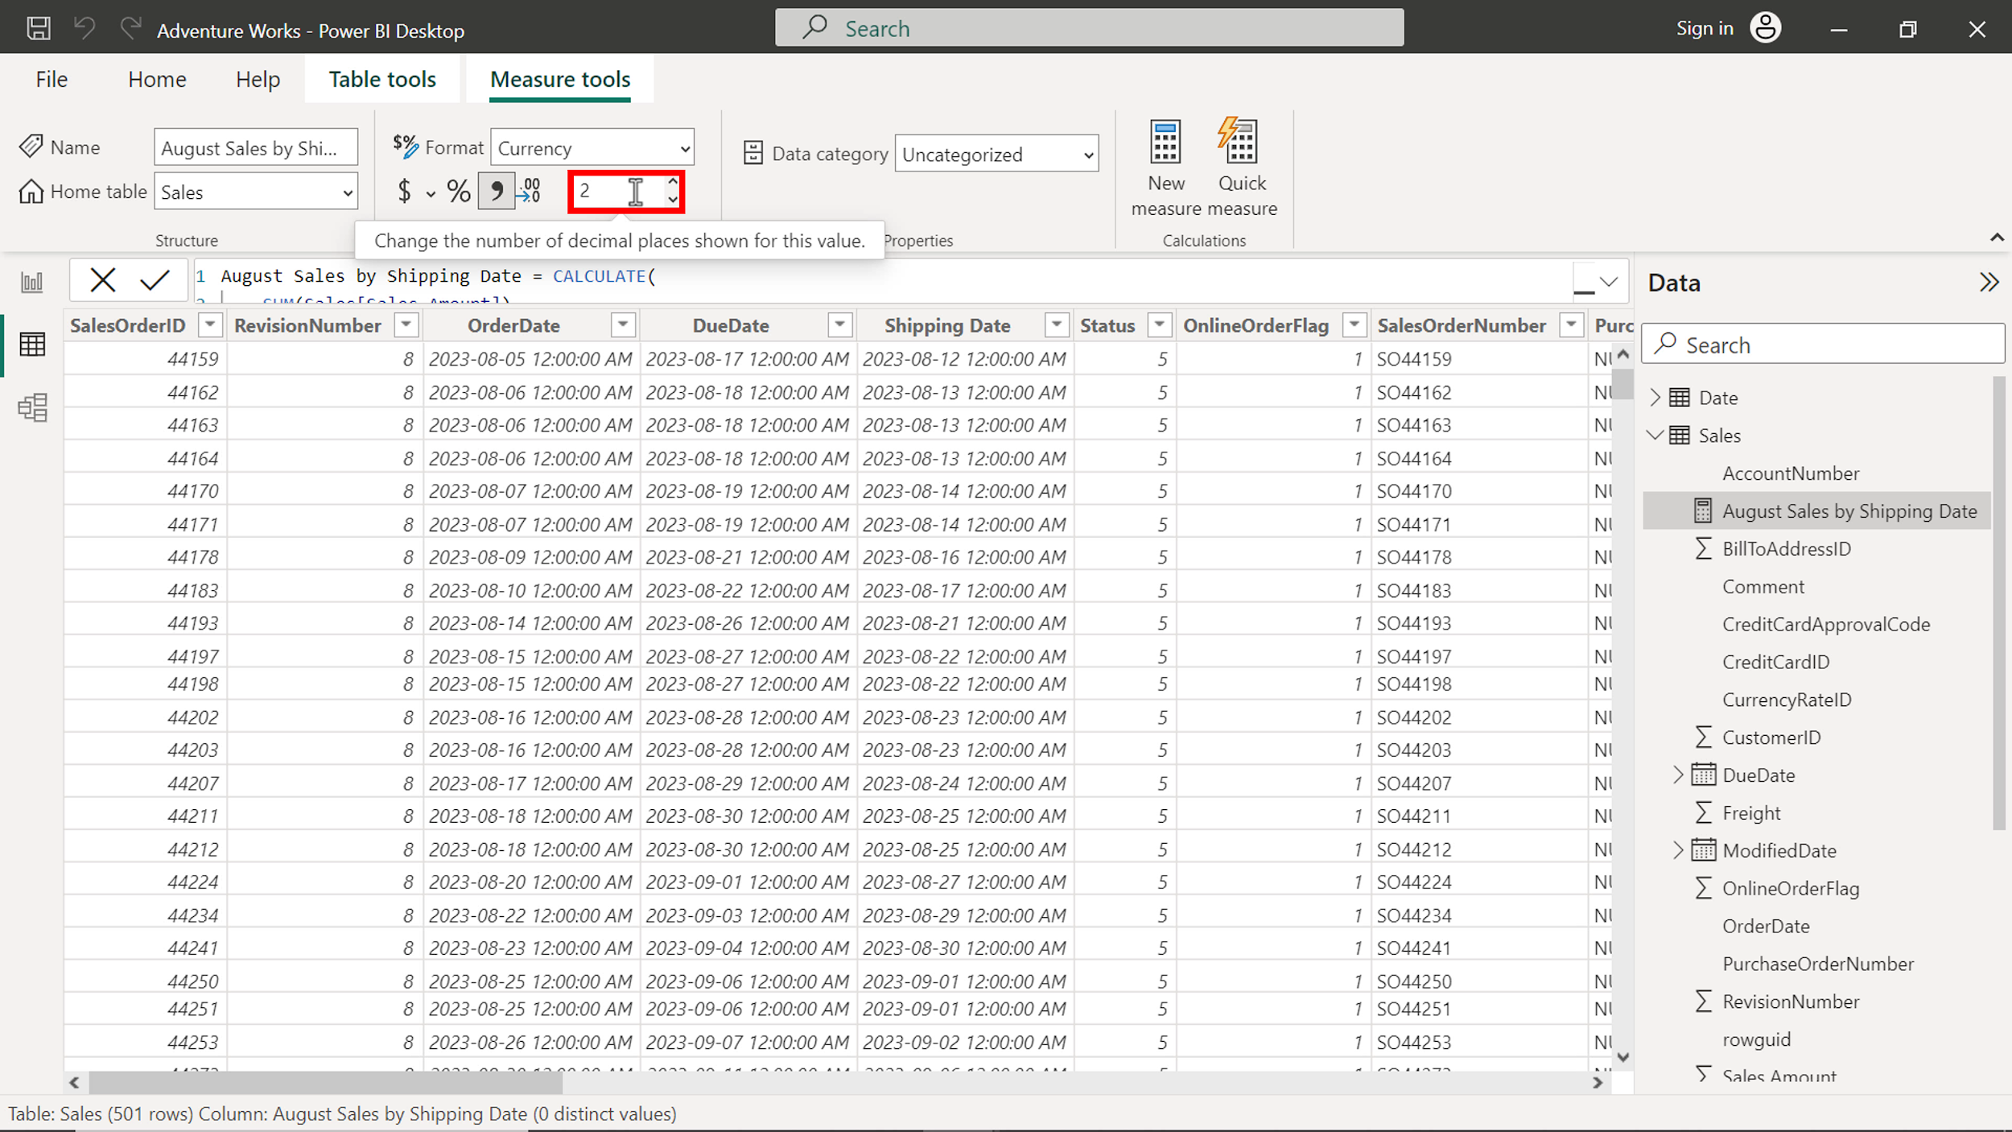

You can view the results of the measure in the following diagram:

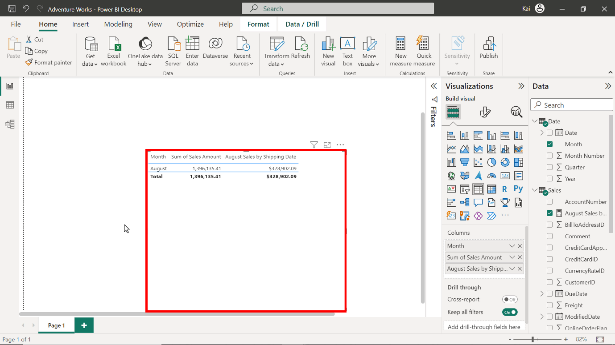

## **Step 4: Save the Power BI project.**

* To save the project, open the File menu, select Save As, and provide an appropriate name for the project along with a path to the folder on your computer.

## **Conclusion**

With these steps, you have successfully created one quick measure using the Power BI desktop interface and another by writing a DAX query. You can now analyze Adventure Works data based on the analytical and business requirements.

Remember that when using DAX formulas, always ensure they are correctly formatted and that the column names match the actual column names in your data.